**Appendix** **1:** Means and standard deviations for each trial of all thirty participants

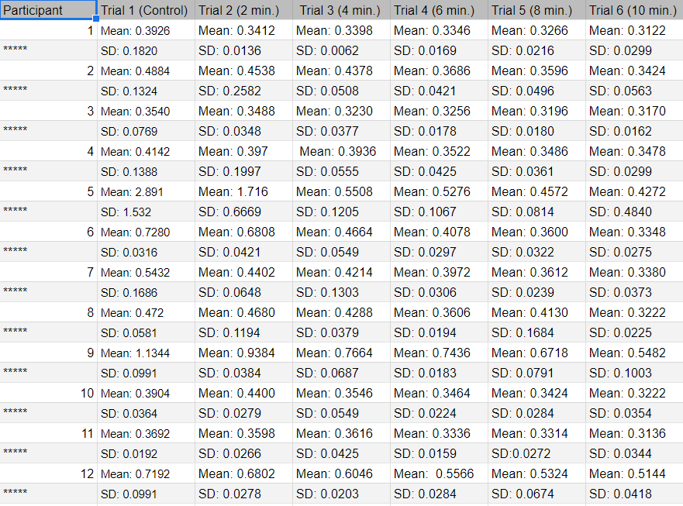

Means and sample standard deviations for each trial. The first column represents the participant and each column afterwards represents the subsequent trials.

**Appendix 2:** Means and standard deviations for each trial of all thirty participants

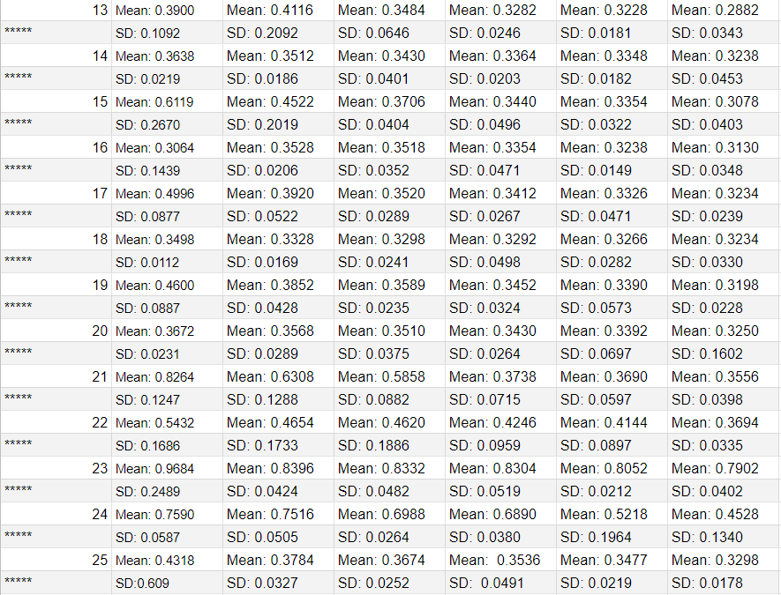

Means and sample standard deviations for each trial. The first column represents the participant and each column afterwards represents the subsequent trials.

**Appendix 3:** Means and standard deviations for each trial of all thirty participants

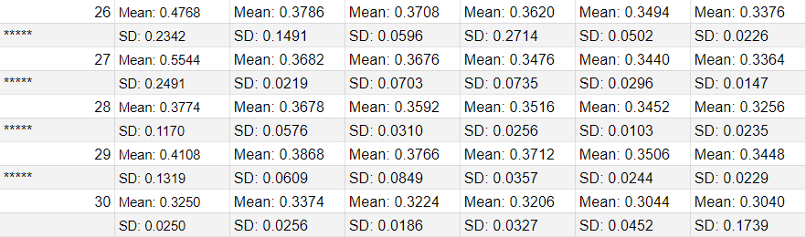

Means and sample standard deviations for each trial. The first column represents the participant and each column afterwards represents the subsequent trials.